BLAKE’S COTTAGE UPDATE OCTOBER 2016
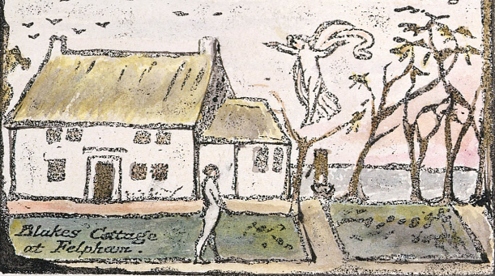
Over the past twenty years the fabric of Blake’s Cottage has been allowed to deteriorate and our first concern has been to safeguard the structure of the building while we move towards a full and complete restoration.
In the best practice of modern conservation, we are endeavouring to retain as much of the historic fabric of the Cottage as possible. Three structural surveys of the building have been carried out – one with a firm of surveyors who have an expertise in historic buildings, the second with an experienced thatcher, and the third with a structural engineer. The only urgent problem found was the condition of the roof. So acting on the detailed instructions of the structural engineer, twenty supports have been put in at points identified by the survey. We now believe the structure of the building is secure for the foreseeable future. The thatch is still deep and weatherproof and when the old straw is removed, it will enable us to fully inspect, mend or replace the failed wooden beams.
We have been in contact with Historic England (formerly English Heritage) and while the significance of the Cottage is appreciated, the building is not on Historic England’s At Risk Register. Two conservation officers from Arun District Council have made a preliminary visit to the Cottage and we will be following their guidelines & advice during the renovation.
The Cottage is subject to three weekly visits, is regularly inspected & cleaned and the garden is being cared for and maintained. The garage is also being used by a local resident that offers additional presence and security. We will continue to monitor the situation as we move towards the beginning of the restoration. If further short-term problems arise then we will address these as necessary.
The Trust has completed Stage One - raising the money needed to purchase the Cottage together with the associated costs of fundraising, surveys, legal fees, conveyancing and insurance. The financial target was reached but not exceeded and so there are no funds available to commence Stage Two - the restoration work. We are now actively seeking funds for this and are advised that around £500,000 will be needed. It took several years to raise the initial funds to purchase the cottage and we can expect a similar time frame to raise the monies for the restoration. Once the funds are in place the restoration process can confidently begin.
Once Stage Two has begun we can then commence Stage Three - the creation of a visitor centre. The original Cottage is a small physical space and for the comfort & safety of visitors and for the economic viability of the project, there needs to be a visitor centre.
There has been a lot of speculation about the ultimate use of the cottage. It remains important to us that the Cottage and gardens are open to the local community on a regular basis as well as to the general public and to the international community of visitors. Firstly, we want to encourage people to visit the Cottage on open days and experience the working of an exact replica of Blake’s original Eighteenth Century Wooden Rolling Press. Secondly, we want to invite artists & poets to visit, stay, be inspired by, and work in the Cottage. We also want to use the new visitor centre for public events, workshops and exhibitions.
The Cottage will never cater for large numbers of people – it is just too small. But more fundamental than size is our aspiration to escape the tyranny of numbers.
Finally, we believe Blake’s Cottage should be measured less by who comes in through the front door, though this is important, but rather more by what comes out of that door. In time we hope William Blake and his Cottage will inspire a stream of creativity, prophecy and imagination.
For over 300 years the Cottage has been in private hands. The Trust is now committed to opening its doors to the public and to creating a centre that will truly honour the home of William Blake – a place of beauty, truth and creativity.
If members of the local community wish to generously donate to the restoration, then please visit the website of Blake’s Cottage. www.blakecottage.org/donate/
Peter Johns, Michael Phillips, Tim Heath - Trustees of The Blake Cottage Trust

